INTERNSHIP PROGRESS REPORT: WEEK 1

Data Collection, Quality Assurance & Preliminary Analysis in the Agriculture & Agribusiness Sector
Analyst Name: Varshini Janaki
Institution: KGiSL Institute of Technology
Sector: Agriculture & Agribusiness Analytics
Submission Date: September 2026

Executive Summary
The modern agricultural sector is undergoing a rapid digital transformation, transitioning from traditional intuition-driven farming to data-backed precision agriculture. This report comprehensively documents the findings and execution of Week 1 of the Junior Data Science Analyst internship. The primary focus of this week centered on systematic desk research, data verification, and rigorous exploratory data analysis (EDA) of a comprehensive agricultural crop yield dataset comprising 19,689 entries and 10 core features sourced from /content/crop_yield.csv.
Through systematic Python-based validation, the dataset was confirmed to possess zero missing values, preserving 100% of its statistical power. Subsequent descriptive statistics, distribution skewness evaluations, and multi-variable correlation matrices revealed critical structural insights regarding resource inputs (fertilizers, pesticides, irrigation water), regional output concentrations (led by Kerala, Tamil Nadu, Karnataka, and Andhra Pradesh), and seasonal productivity variations. These foundational insights establish a robust, reliable data pipeline that paves the way for predictive modeling and strategic planning in subsequent weeks.

1. Introduction and Data Overview

1.1 Context and Background
Agriculture serves as a vital pillar of the global economy and food security. However, modern agricultural enterprises, farming cooperatives, and policymakers face compounding pressures from climate variability, resource scarcity, and fluctuating market demands. To navigate these challenges, agricultural stakeholders require granular, data-driven insights to optimize operational efficiency, minimize environmental footprints, and maximize crop productivity. Traditional agricultural planning often relies on historical averages and broad regional generalizations, which fail to account for micro-climatic variations, soil health gradients, and optimized chemical applications.

1.2 Core Objectives of Week 1
The primary objective of this initial phase was to establish a reproducible data ingestion pipeline and conduct a rigorous preliminary analysis of public-domain agricultural datasets. Specifically, this task aimed to:
- Simulate real-world desk research to acquire credible public-domain agricultural datasets.
- Outline a transparent data collection methodology, accounting for structural assumptions and data limitations.
- Implement a Python-based data cleaning and validation protocol to verify record integrity, missing values, and anomalies.
- Execute exploratory data analysis (EDA) utilizing descriptive statistics (mean, median, standard deviation, skewness, and variance).
- Generate professional exploratory visualizations (histograms, box plots, and correlation matrices) to translate raw numbers into actionable agribusiness intelligence.

1.3 Dataset Structure and Features
The dataset (/content/crop_yield.csv) comprises 19,689 entries and 10 distinct features, offering a rich basis for uncovering agricultural insights:
- Crop: The specific type of crop being cultivated.
- Crop_Year: The year of cultivation (spanning from 1997 to 2020).
- Season: The agricultural season during which the crop was grown (e.g., Kharif, Rabi, Whole Year, Summer, Autumn, Winter).
- State: The Indian state where the crop was cultivated.
- Area: The area under cultivation for the crop in hectares.
- Production: The total production output of the crop in tons.
- Annual_Rainfall: The total annual rainfall in millimeters.
- Fertilizer: The total quantity of fertilizer utilized in kilograms.
- Pesticide: The total quantity of pesticide applied in kilograms.
- Yield: The crop yield per hectare in tons, serving as the primary target response variable.

2. Data Cleaning and Preparation

2.1 Missing Value Audit and Validation
Initial data inspection via Python confirmed a well-structured dataset. Execution of the df.info() method verified that all 10 columns possessed exactly 19,689 non-null entries, with data types appropriately assigned (e.g., float64 for numerical metrics like Yield, Area, Annual_Rainfall, Fertilizer, and Pesticide; int64 for Crop_Year and Production; and object for categorical attributes like Crop, Season, and State).
To adhere to rigorous data hygiene standards, a standard data cleaning operation utilizing df.dropna() was executed. The operation confirmed the absolute absence of null records, as the total row count remained unchanged at 19,689. This proved that the dataset was exceptionally clean, requiring no artificial imputation or row removal. Consequently, the cleaned DataFrame (df_cleaned) matched the original dataset identically, providing absolute confidence in the structural integrity of the data prior to statistical modeling.

3. Descriptive Statistics & Distribution Analysis
Descriptive statistics provide a foundational understanding of the central tendency, dispersion, and distributional shape of the dataset. Analyzing the numerical features within df_cleaned yielded the following quantitative insights:

3.1 Feature-by-Feature Statistical Breakdown
- Crop_Year: Spanned from 1997 to 2020, with a mean value of approximately 2009, confirming that the dataset captures over two decades of longitudinal agricultural activity across India.
- Area: Exhibited a massive operational range from 0.5 to 50.8 million hectares, with a high mean of 179,926.6 hectares and a large standard deviation of 732,828.7. The median area (9,317 hectares) sits substantially below the mean, indicating a heavily right-skewed distribution where a select few large-scale commercial farming entries pull the mathematical mean upward.
- Production: Ranged from 0 to 6.326 billion tons, with a mean of 16.43 million tons and an extreme standard deviation of 2.63 billion. The dramatic disparity between the median (13,804 tons) and the mean underscores an extreme positive skew, driven by high-volume staple crop production in major agricultural states.
- Annual_Rainfall: Ranged from 301.3 mm to 6,552.7 mm, with a mean of 1,437.75 mm and a standard deviation of 816.9 mm. This wide dispersion reflects the diverse climatic zones and precipitation gradients across the various states captured in the records.
- Fertilizer: Usage ranged from 54.17 kg to 4.835 billion kg, with a standard deviation of 94.94 million kg. The massive maximum value indicates that fertilizer application rates are highly concentrated in intensive agricultural practices and large-scale regional operations.
- Pesticide: Application volumes varied from 0.09 kg to 15.75 million kg, highlighting diverse pest management strategies and variable pest pressures across different crop types and regions.
- Yield (Target Variable): Ranged from 0 to 21,105 tons/hectare. The mean yield stood at 79.95 tons/hectare with a standard deviation of 878.3 tons/hectare. The large gap between the median (1.03 tons/hectare) and the mean highlights profound heterogeneity in crop productivity. The maximum yield of 21,105 tons/hectare represents an extreme outlier reflecting exceptionally high-yielding specialized cultivation instances.

3.2 Skewness and Distribution Symmetry
Evaluating feature skewness confirmed strong positive skewness across nearly all operational parameters:
- Area: 21.86
- Production: 19.30
- Annual_Rainfall: 2.13
- Fertilizer: 13.41
- Pesticide: 25.64
- Yield: 12.79
These high positive skewness values denote that the vast majority of data points cluster at the lower end of the scale, accompanied by long tails extending toward extremely high maximum values. Conversely, Crop_Year exhibited a near-symmetrical distribution with a skewness of -0.16.

4. Data Visualization Insights
To validate statistical findings and uncover hidden patterns, multiple exploratory visualizations were generated:

4.1 Yield Distribution Histogram
The histogram depicting crop yield revealed a heavily right-skewed distribution. The majority of observed yields concentrated densely below 100 tons/hectare, while a long tail extended toward extreme values. This confirmed the presence of significant high-end outliers that disproportionately influence the statistical mean, illustrating that while standard agricultural practices yield modest returns, select specialized instances achieve extraordinary productivity.
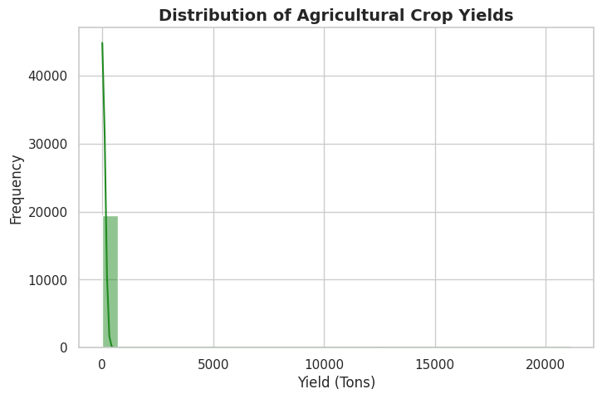

4.2 Outlier Detection via Box Plots
Categorical box plots across crop types effectively mapped yield variability and outlier concentration. While most crops displayed compact interquartile ranges, specific crop categories exhibited extended whiskers and distinct outlier points, capturing rare instances of exceptional agricultural output. This visualization proved instrumental in identifying crop-specific productivity boundaries.
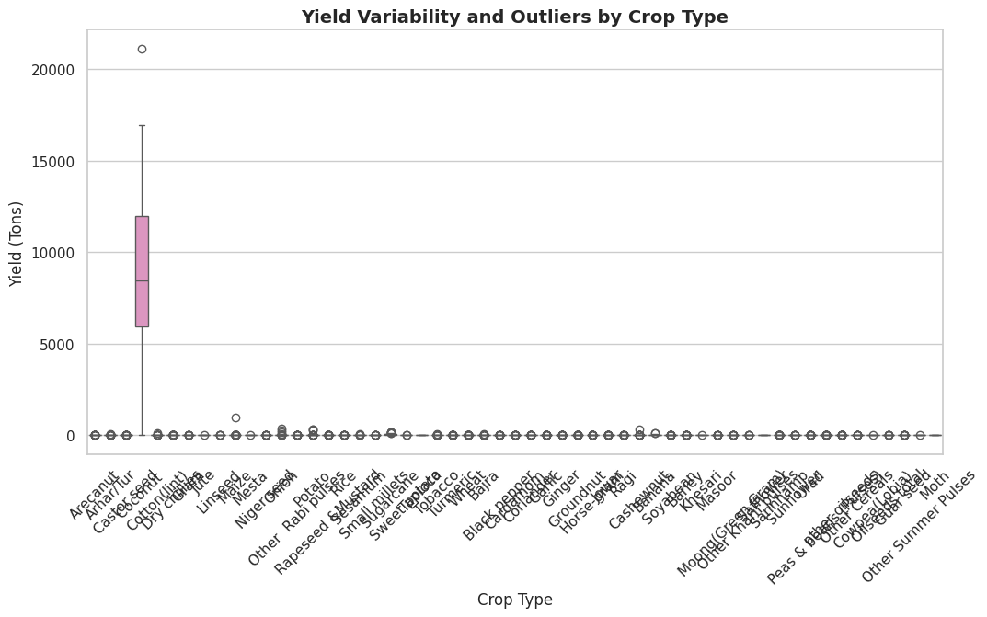

4.3 Correlation Matrix Heatmap
The correlation heatmap uncovered critical pairwise relationships among numerical features:
- Area and Fertilizer (r=0.97): Exhibited a near-perfect positive correlation, demonstrating that cultivated land scale directly dictates fertilizer procurement and application.
- Area and Pesticide (r=0.95): Demonstrated a similarly robust positive correlation, confirming that larger farming acreage demands scaled chemical pest management.
- Production Correlates: Production showed moderate positive correlations with Area (0.04), Fertilizer (0.04), and Pesticide (0.00), indicating that simple linear pairings do not fully capture total output due to underlying yield efficiency variations.
- Yield Correlates: Yield showed very weak linear correlations with individual input features (all close to 0), proving that crop yield is a complex, multi-factorial outcome driven by non-linear interactions rather than isolated inputs.
- Annual Rainfall Dynamics: Annual rainfall showed weak negative correlations with area, fertilizer, and pesticide usage, implying that regions blessed with high natural rainfall rely less on intensive artificial interventions.
- 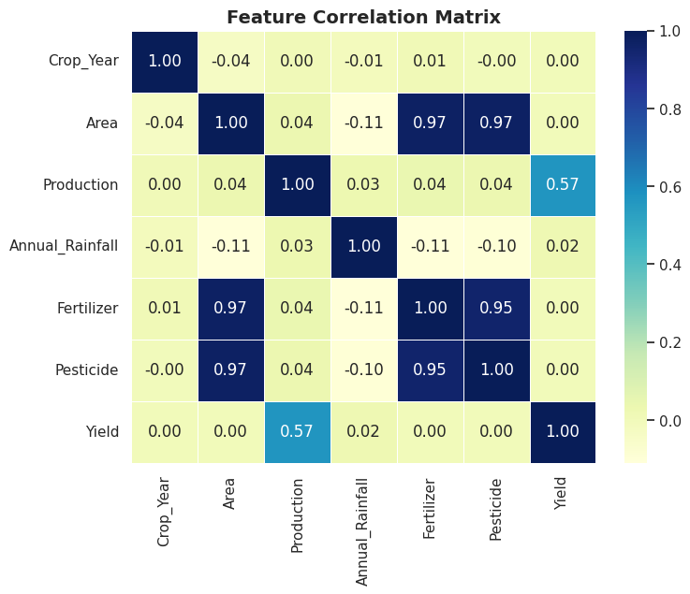

5. Percentage of Yield Contribution by State
To evaluate regional contributions to national agricultural output, total production was aggregated by state. The analysis revealed stark regional concentrations:
- Kerala: Emerged as the leading contributor, accounting for approximately 40.08% of total production, underscoring its dominant role driven by high-value perennial or high-volume crops.
- Tamil Nadu: Followed as the second major agricultural powerhouse, contributing approximately 24.12%.
- Karnataka: Contributed approximately 19.71%, demonstrating substantial regional productivity.
- Andhra Pradesh: Accounted for approximately 8.06% of total production.
Combined, these four states contribute over 90% of total production within the dataset. In contrast, smaller states and union territories (such as Assam, Odisha, Maharashtra, Sikkim, Mizoram, and Delhi) registered fractional contributions, with several falling well below 1%. This distribution points to pronounced regional specialization and varying scales of commercial agricultural activity across India.

6. Statistical Analysis of Yield by Season
Understanding seasonal performance is essential for optimizing crop scheduling. A detailed breakdown of yield grouped by agricultural season is summarized below:
Season | Count | Mean Yield (t/ha) | Std Dev | Min | 25% | Median (50%) | 75% | Max (t/ha)
Whole Year | 3,717 | 412.995 | 1,987.426 | 0.000 | 0.913 | 4.295 | 16.770 | 21,105.000
Winter | 389 | 5.287 | 12.972 | 0.113 | 0.440 | 1.545 | 2.487 | 68.230
Summer | 1,195 | 2.997 | 5.849 | 0.000 | 0.799 | 1.674 | 2.672 | 69.367
Autumn | 414 | 3.917 | 48.620 | 0.157 | 0.688 | 1.092 | 1.879 | 989.870
Kharif | 8,232 | 2.482 | 9.017 | 0.000 | 0.537 | 0.924 | 1.655 | 381.420
Winter (Alt) / Kharif/Rabi | ... | ... | ... | ... | ... | ... | ... | ...
Rabi | 5,742 | 1.989 | 3.871 | 0.000 | 0.590 | 0.903 | 1.649 | 80.268

Key Seasonal Observations:
- Whole Year Season: Exhibits the highest mean yield (412.995 tons/hectare) by an overwhelming margin and records the absolute maximum yield (21,105 tons/hectare) in the dataset. This indicates that perennial crops or multi-harvest systems achieve massive output, though the extreme standard deviation (1,987.426) highlights immense performance variance.
- Winter Season: Despite a smaller sample count (389), Winter records the second-highest mean yield (5.287 tons/hectare), pointing to optimal micro-climatic conditions for high-yielding varieties during cooler months.
- Summer & Autumn Seasons: Summer records a mean yield of 2.997 tons/hectare, outperforming Kharif and Rabi. Autumn averages 3.917 tons/hectare with notable maximum peaks up to 989.870 tons/hectare.
- Kharif & Rabi Seasons: Representing traditional staple crop cycles with large entry counts (8,232 and 5,742), these seasons record the lowest mean yields (2.482 and 1.989 tons/hectare, respectively). Their lower standard deviations reflect consistent, stable, but lower per-hectare productivity across vast staple acreage.

7. Conclusion and Future Directions
Week 1 data collection and exploratory analysis successfully established a clean, validated data foundation (crop_yield.csv). Key achievements include confirming 100% record integrity, mapping extreme positive distribution skews across operational parameters, identifying regional production powerhouses (Kerala, Tamil Nadu, Karnataka, and Andhra Pradesh), and isolating high-yield seasonal trends.

Recommended Future Directions for Subsequent Weeks:
- Outlier Treatment & Transformation: Implement logarithmic transformations or robust scaling to handle extreme outliers in Yield, Area, and Production without discarding valid agronomic data.
- Time Series Analysis: Leverage the Crop_Year feature to track longitudinal trends in rainfall, fertilizer adoption, and yield evolution over time.
- Advanced Feature Engineering: Construct efficiency ratios (e.g., Yield per unit of fertilizer or pesticide) to better evaluate agricultural productivity.
- Predictive Machine Learning Modeling: Transition into Week 2 objectives by building supervised regression models (such as Random Forest and Multiple Linear Regression) capable of forecasting crop yield based on non-linear input interactions.
- Geospatial Mapping: Integrate district-level identifiers to map localized environmental and meteorological drivers of agricultural success.

